**EXP6 : DESIGN AN OBSTACLE DETECTOR AND DISTANCE MEASURING DEVICE**

**THEORY :**

**CIRCUIT DIAGRAM:** 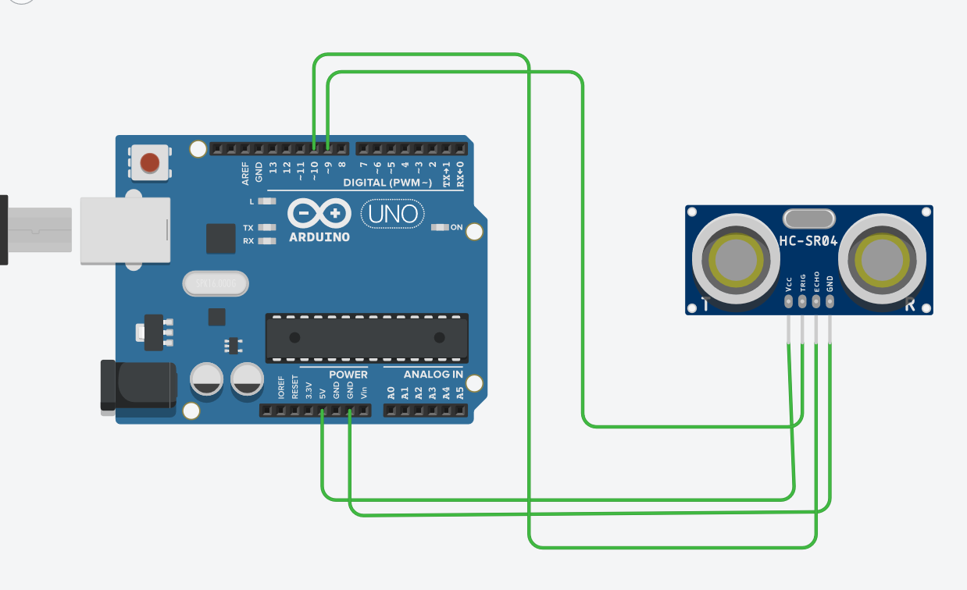

**CONCEPT USED :** In this experiment first we used the basics of electronics in connecting the breadboard connections and the concept of the connections of the Arduino with the ultrasonic sensor.

The concept of coding of the Arduino for the distance measuring in ultrasonicsensor is also used.

**LEARNING AND OBSERVATIONS**:

Through this experiment we can learn the use and the applications of Arduino and the ultrasonicsensor for the obstacle detection and distance measuring.

We can also learn the coding for the Arduino for the ultrasonic sensor from this experiment .

We can detect any obstacle and measure that distance by using an ultrasonic sensor.

**PROBLEMS AND TROUBLESHOOTING :**

We mainly face problems in making the properconnections in the breadboard and the connections ofultrasonicsensor with the Arduino.

And the code of the Arduinofor connecting ultrasonic sensor should be given properly.

**PRECAUTIONS :**

One should be concentrated while making the connections of breadboard and Arduino with the ultrasonic sensor.

And also the code of Arduino should be checked twice.

The use of extra connecting wires should be decreased.

**LEARNING OUTCOMES :**

We can Learn the a real life application from this experimentlike how an ultrasonicsensor detects an obstacle and measuring its distance .

We can also learn the coding for the Arduinofor the ultrasonic sensor.